Rate Limiting Proxy Dev-Log:
Why?
I’ve spent the last 2 years building small, user facing applications, or privately commissioned API services for businesses. Whiles these are great practical experience and are useful and successful for their design, I wanted to build something designed for a larger scale, something that would both strengthen and demonstrate my understanding of http, concurrency, and the client/server relationship. I wanted to do something without any AI generated code, to prove to myself that I truly understand the processes that until now I sometimes struggled with, such as channels, goroutines, testing and race conditions.
The Problem
All servers have an upper limit on how much work they can handle in a fixed window of time. Servers need to fairly distribute this work amongst the clients that make requests from it. Generally, you do not want one client consuming all the servers available processing power, leaving nothing for any others that try to use it. Secondly, this processing and networking power is not free, and often it’s desirable to control usage to manage and put a cap on cost. There are also downstream dependencies to consider, the server may be able to handle the requests fine, but if it in turn makes API calls to other services or databases to achieve its function, then we need to consider the capacity of those services too.
Something needs to control how many requests per client can reach a server at any time. The naïve approach to this would be to say, “no more than X requests per Y amount of time, per client”. While this is an improvement on having no limits at all, it’s not a complete solution. The issue is that requests do not always come neatly as expected in the time window we as developers would define. Imagine we said, “only 100 requests per real world second, according to UTC”. Well, if 100 requests came at the last half of the first second, and another 100 requests came at the first half of the next second, now we have an effective rate of 200 requests per second. This is known as the “boundary burst” problem.
We also must consider what exactly is a client, and how can we ensure balance in that regard. If a client is considered an IP address, then we unfairly punish anyone behind a shared NAT or corporate proxy, considering them as a single entity. API-key based requires authentication to be resolved before the limiter even runs. The exact definition of the “client” will need to be somewhat fluid, if it is to work holistically. We should design this definition to be dependent on which “route” the client is requesting from. If it is a log-in endpoint, consider the IP. If the user is already identified and authenticated, then we can consider the user ID instead.
We need a more nuanced approach to rate limiting if we are to solve this effectively, something that considers the wider scope of usage from each client, controlling the average rate at which resources are consumed over an arbitrary amount of time, and for that we need an algorithm.
The Algorithm
The first logical step was to decide on an algorithm that would form the foundation of the proxy and perform the rate limiting itself. Researching the topic uncovered algorithms I hadn't previously encountered: the sliding window and the token bucket.
Considering again the problem – "no more than X requests per Y time". The sliding window defines the "Y time" window dynamically, constantly recomputing what the current second is. This window of time has a capacity tied directly to it, and the number of requests allowed will never exceed that limit within the time window. So in our example before, where 100 requests came at the last half of the first second – now the window is completely full and will not open again until those requests pass through it, and once they have passed, we again have space for another 100. A client can never burst beyond the fixed capacity of the time window; it must wait. This algorithm makes a lot of sense when we are expecting sustained traffic.
The token bucket also has a fixed capacity, but it is a more appropriate solution for clients we expect to make requests in bursts. A token bucket can spend all its tokens at once, and rather than waiting for a window to pass, it then slows the rate at which further requests can be made to a smaller "refill rate". The rate at which requests can be spent (the refill rate) is decoupled from the capacity itself, so the token bucket can have a larger capacity, allowing clients to spend more at once. The requests continue to process at the refill rate until they stop being made, at which point the number of requests allowed starts to accumulate again up to the capacity of the bucket.
For this reason, if we expect clients to make requests in a more sustained pattern over time, the sliding window approach makes sense and will smooth the response rate in a controlled way. If we expect the client to lie dormant for periods and then make lots of requests at once, the token bucket allows for this without delaying the process with a series of spiked responses. It will deliver a large amount, followed by a controlled amount over time.
Both algorithms solve the capacity-over-time problem in different ways; both are viable and fit for certain expected usage behaviours. Token bucket front-loads a large burst then drops to the refill rate, whereas sliding window caps every window at the same limit repeatedly which, in aggregate over time, produces a steadier delivery pattern than token buckets front-load, even though neither algorithm forces even spacing within a single window.
Algorithm design
I decided to build this app using a token bucket, as it was the one that interested me the most, and throughout all the other projects I have worked on to date, it feels beneficial to be able to store up a large burst of requests per user, the design feels more elegant and fit to purpose, although I am interested in exploring alternatives in other builds.
I defined the structure of the token bucket as well as a constructor, with all the fields I deemed necessary for it to function. Two non-obvious fields are the sync.Mutex, and the TimeOfLastRequest.
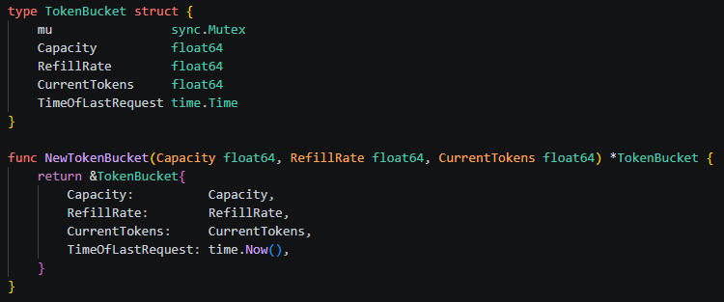
Allow()
My first instinct was that we needed to keep a running counter of tokens in the bucket at all times. How could we possibly know if there are available tokens to spend when a request comes in otherwise?
Well, doing that would be a waste of computing power, and there is a much simpler (and a commonly used) approach. Enter… TimeOfLastRequest.
We know the refill rate of the bucket and its capacity; these are defined by the constructor and are unlikely to change dynamically. By storing two points in time – the time the request is made, and the time of the previous request, we can effectively calculate the time between each, and the difference in tokens based on that time gap.
If the bucket fills at 5 tokens per second, the previous request was 3 seconds ago, and the current request is now, then we can add 15 tokens to the CurrentTokens, and we are up to date again, without any computations taking place between requests.

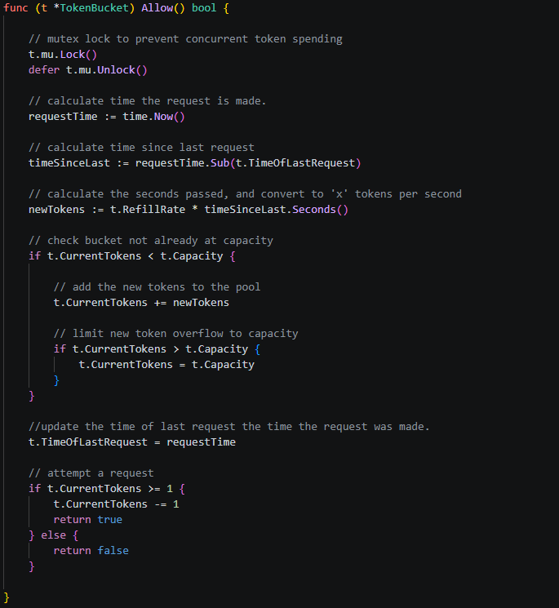

Why a Mutex Lock is necessary / Concurrency Correctness
A mutex lock is a hard requirement for avoiding race conditions, without it, if more than one goroutine attempted to spend the buckets tokens at the same time, then a race condition would occur. Requests will practically never arrive and process one at a time, so this is a foundational design decision that can’t be avoided. By applying a mutex lock during the Allow()function, we prevent any race conditions, or situations where requests simultaneously try to spend the last token/s in the bucket (which would result in overspending into the negatives).
Output race conditions without mutex Locking the Allow() function:
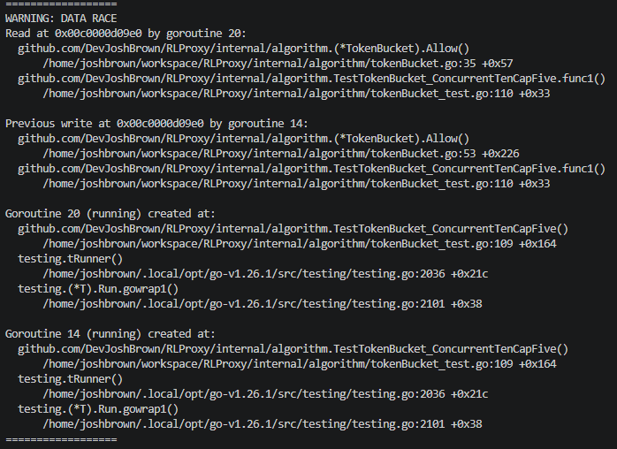
With mutex lock :
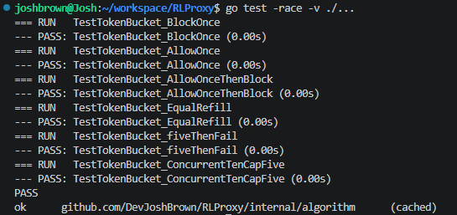
Test:
